- Install git.
git install git -y && git --version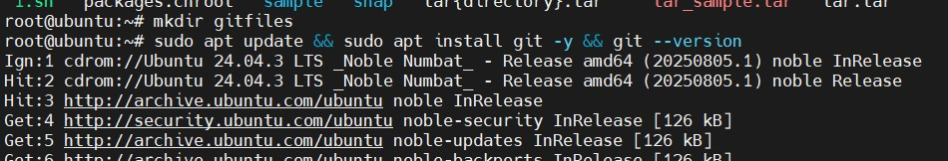
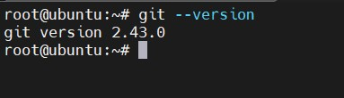

- Create a repo in GitHub with README.md and .gitignore file.
Clicked create repository and added name and visiblility to public and toggled README.md file
Created .gitignore files in the git hub repository
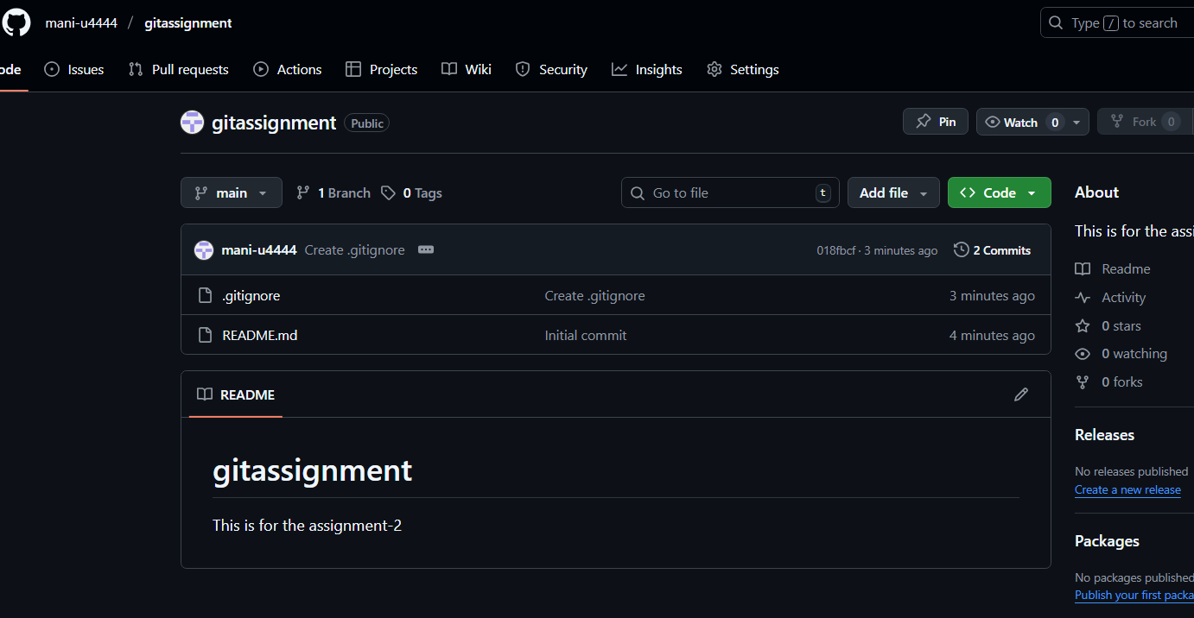
- Clone the created repo to local.
Connected the git to the github by creating the ssh keys in the windows laptop using the command “ssh-keygen” logged on to the .ssh folder in the home directory and initiated cat command on the public key to copy the key, copied the key and added the key in the Github settings-> ssh keys and gcp keys > added keys
Git clone < repo url>
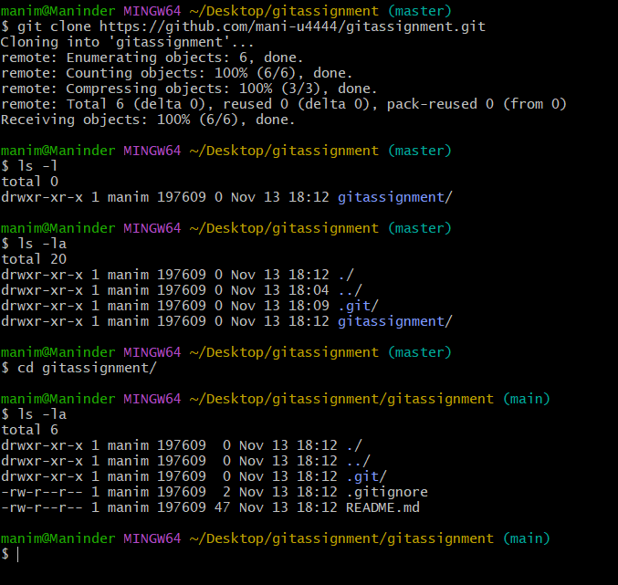
- Create two files in local repo.
Created the two files in the repo with “touch file1 file2”
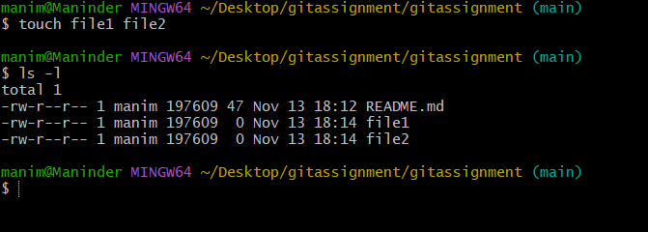

- Commit two files and push to central Repository.
We have to add the git files to the tracking or staging stage using git add .
This command will make the files go tracking and we can see the see if the files are tracked using the command “git status” the tracking are shown under green font.
We can able to make the commit by using the command git commit -m “message”
Git commit -m “two files to central repo”
Now execute ‘ git push -u origin main’ to upload the files to the main branch in the github repository.

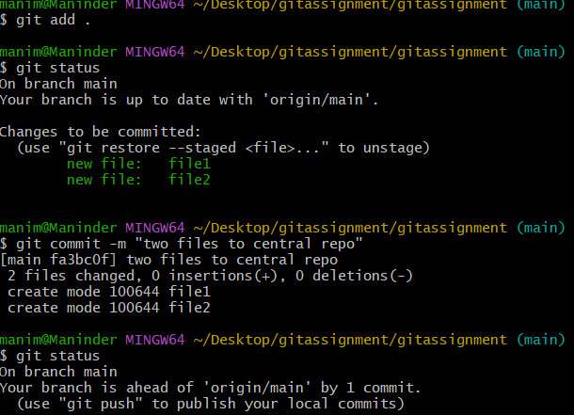
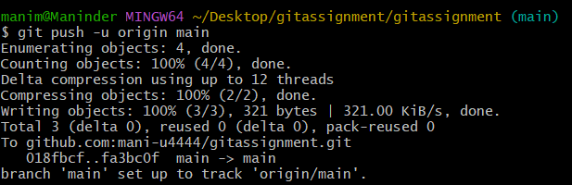
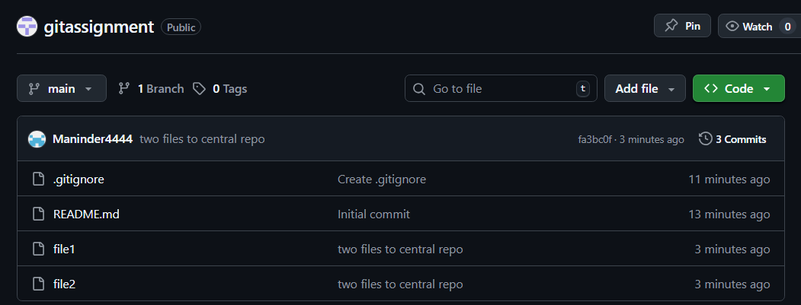

- Create a branch in local and create a sample file and push to central.
Created a new branch in the local using the command “ git branch release’
Created a sample file using the command ‘touch releasebranchfile-local’
Now add the files to stating using the command ‘ git add .’
Now commit the files using the command ‘ git commit -m “ this is the for the releasefile from local’
git push -u origin main to push the files to the main branch on the github repo
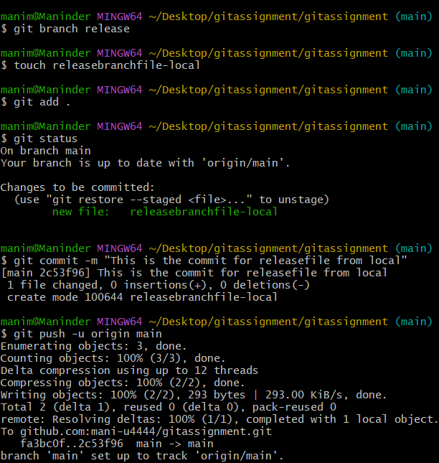
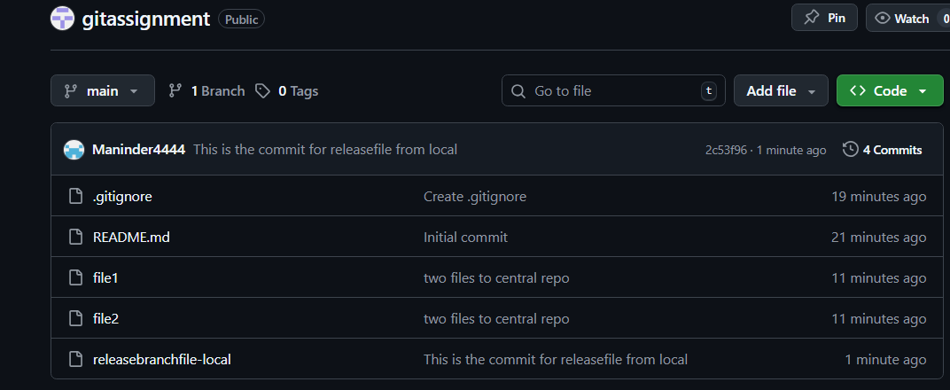
- Create a branch in GitHub and clone that to local.
Created a github branch by clicking main branch button which opens to enter the branch name click below “create branch from the main branch”
Copy the url of the newly created branch and execute the command as follows
Git clone <url>
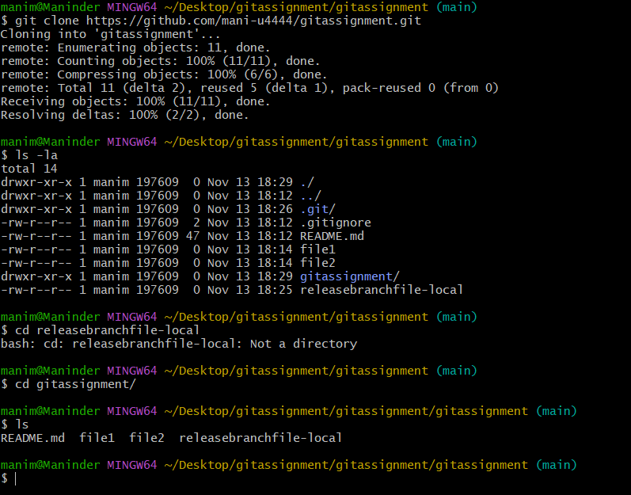
- Merge the created branch with master in git local.
Create a new branch with the name using the following command “ git branch release”
Go to the main branch using the command “ git checkout main”
Enter the command “ git merge release” to merge the release branch with the main branch
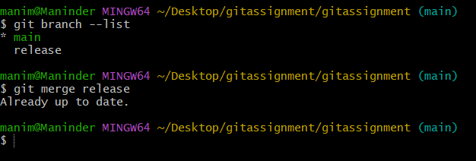
- Merge the created branch with master in GitHub by sending a pull request.

Created a dummy file in newly created branch and performing the pull request to main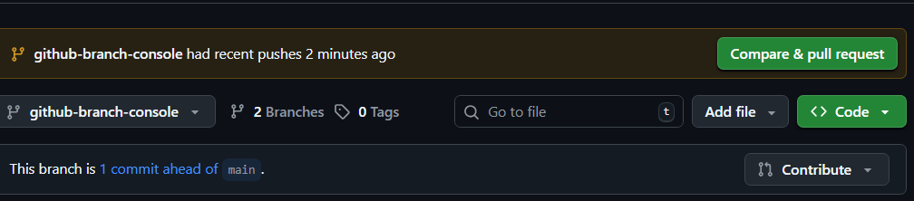
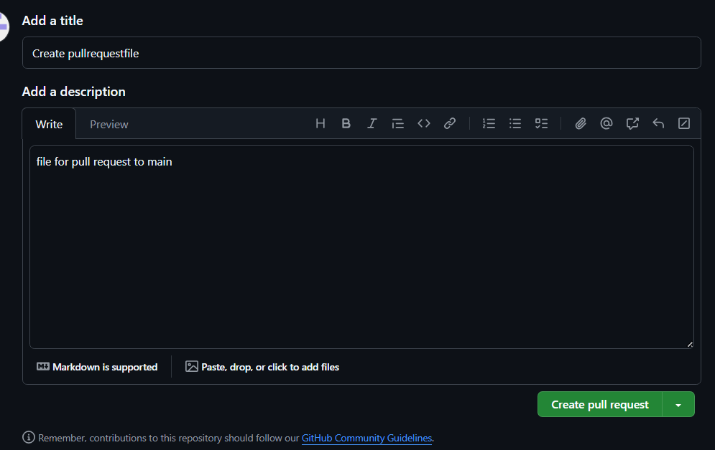
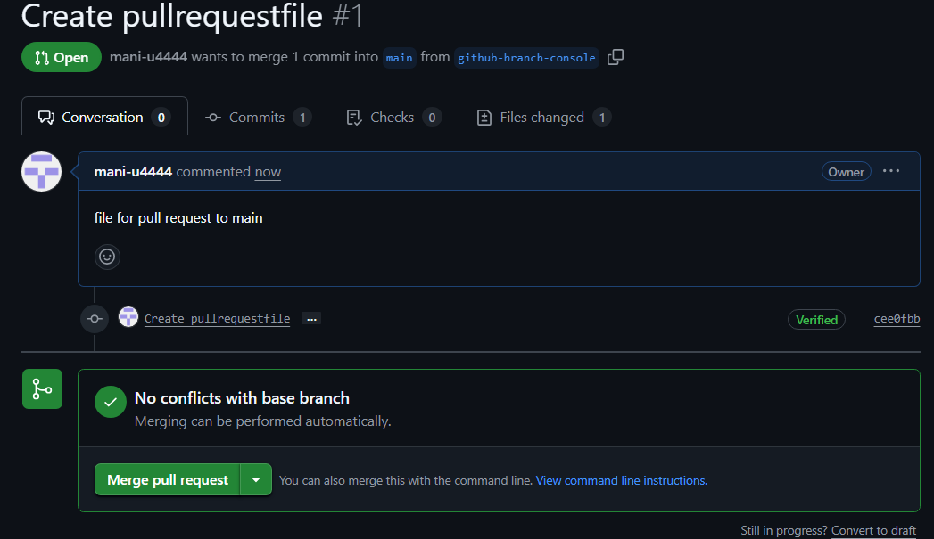
Initiated merge pull request to make the pull request from github-branch-console to the main branch

- Create a file in local and send that to branch in GitHub.
Created a file name file2sendtobranch using the touch command
How added the file to staging area using the command git add file2sendtobranch
Committed the file using the command git commit -m “commit for file2sendtobranch”
Moved to main branch using the command “ git checkout main”

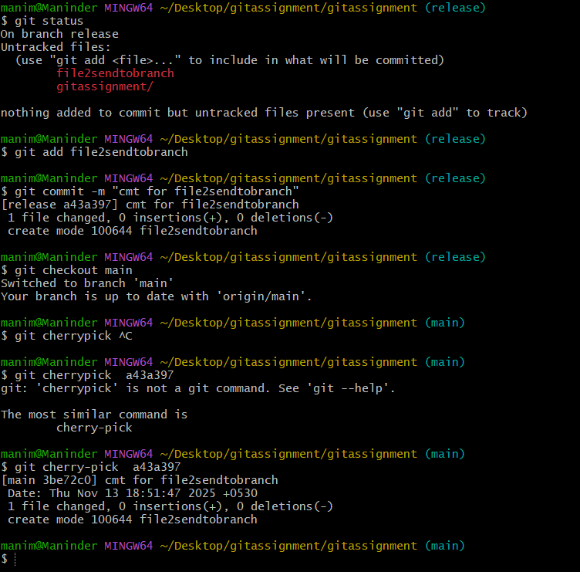
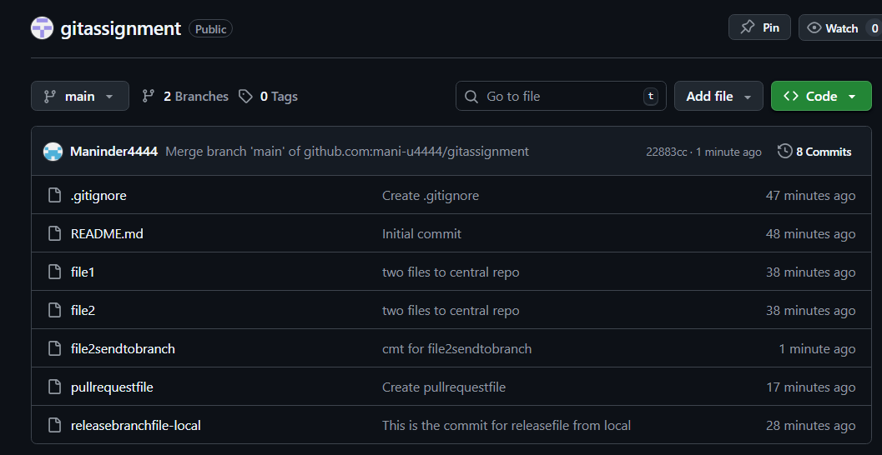
- Clone only a branch from GitHub to local.
Execute the following command to clone the repo ‘ git clone --branch git-branch-console <repository_url>
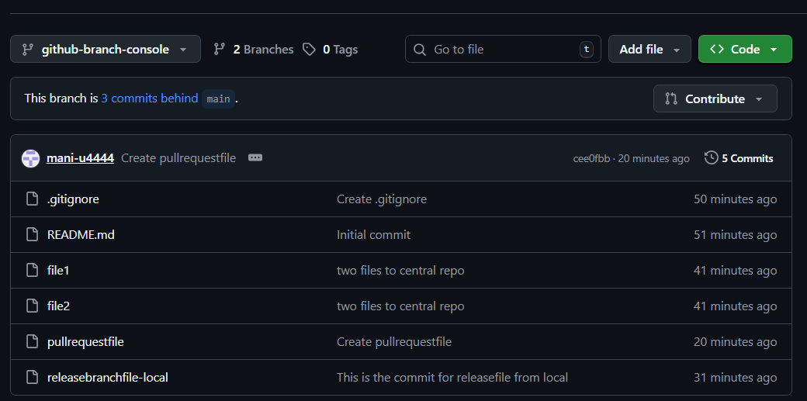
- Create a file with all passwords and make that untraceable with git.
Created a file named ‘password’ with the contents like usernames and password
Opened the file name ‘.gitignore’
Now enter the file name password which was created earlier
Now if we execute the command ‘git add .’ and ‘ git commit’
The file password is discarded to staging and commits and file is untrackable
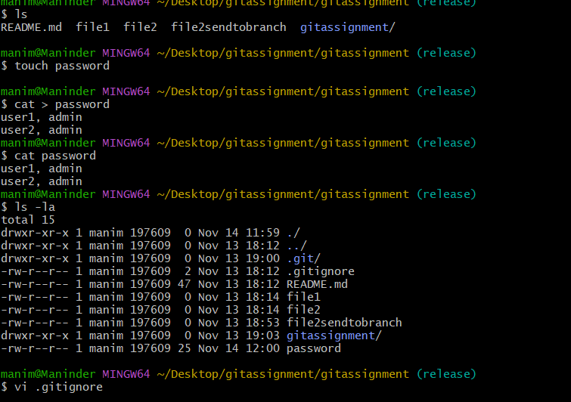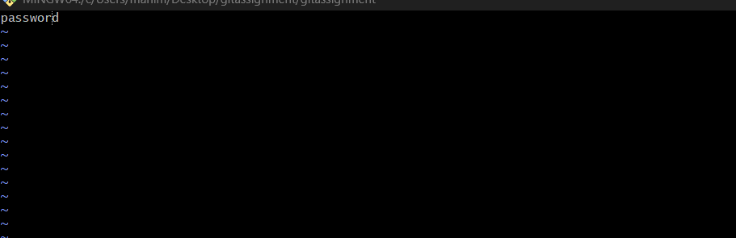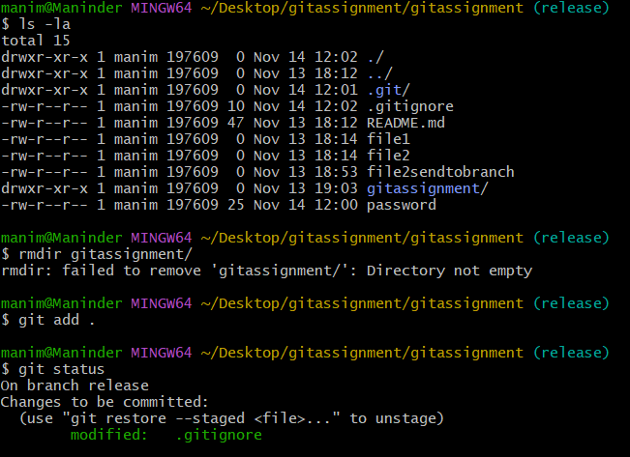
- Revert a committed commit to the older version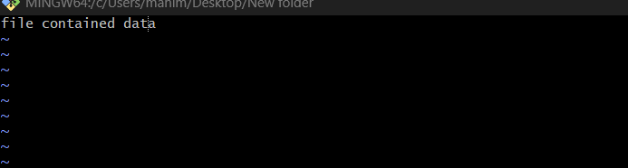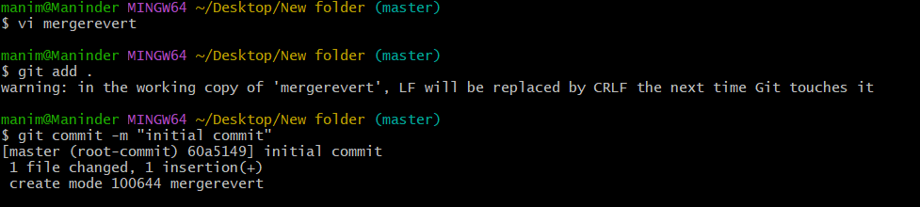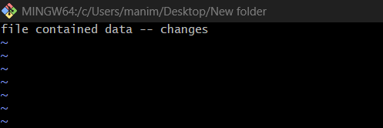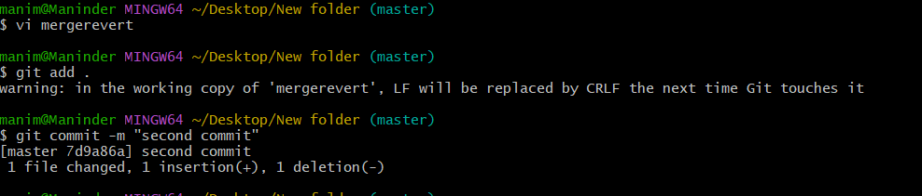

- Make a commit and make that commit reset without saving changes.
We can able to make the tracked files to untracking using the git reset command
Here we have created file3 file4 and file5
And now we have added those files to tracking using the command ‘ git add file3 file4 and file5’
Let say we don’t want the files to go tracking and we want them to untracking we can execute the command ‘git reset’ and those will be back to untracking
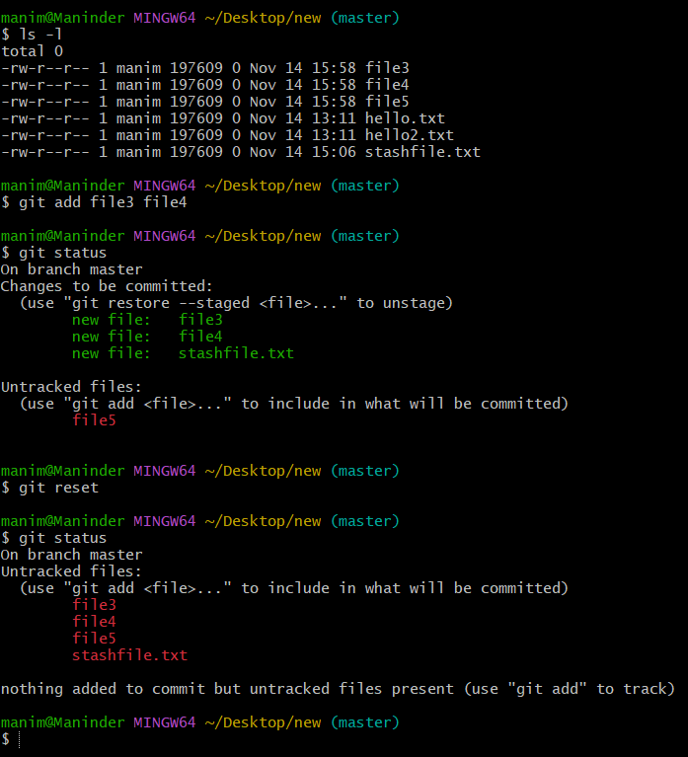
- Push a file to stash without savings the changes and work on another file.
Created a file name stashfile.txt using the touch command
Now git status shows that the file is untracking
Now executed the file to staging area by using the command ‘ git add .’
Now executed the ‘git stash ‘ to move the file to the stash memory
Now when execueted the git status, the file is untrackable

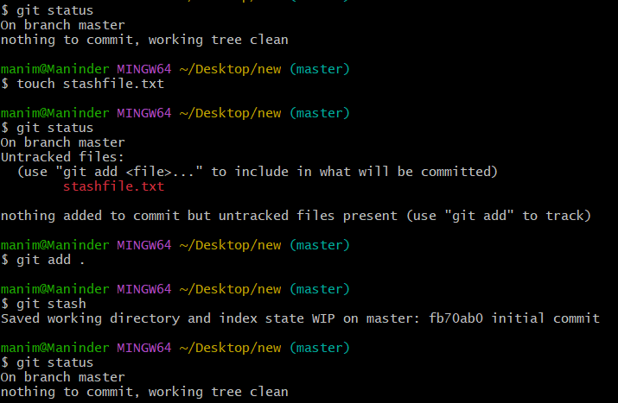
- Undo the stash file and start working on that again.
We can the list of stashed files using the command ‘ git stash list’ and list clearly shows out stashed file
Now we can able to unstash the file using the command ‘ git stash pop’
Executed the git status to see the stashed file back to the tracking state.
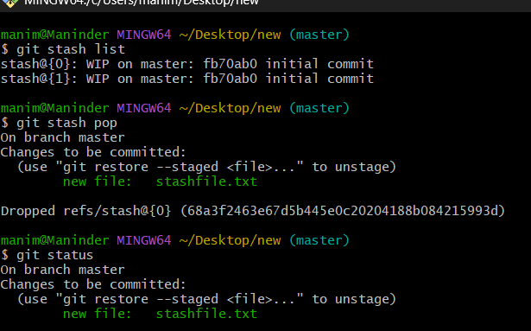
- Generate a ssh-keygen and configure into GitHub.
Connected the git to the github by creating the ssh keys in the windows laptop using the command “ssh-keygen” logged on to the .ssh folder in the home directory and initiated cat command on the public key to copy the key, copied the key and added the key in the Github settings-> ssh keys and gcp keys > added keys

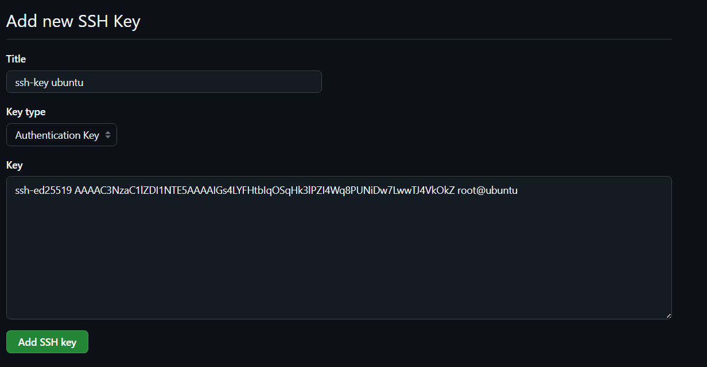

- Configure webhooks to GitHub.
- Basic understanding of .git file.
Git creates a hidden folder called .git when executed ‘git init’ in the project folder.
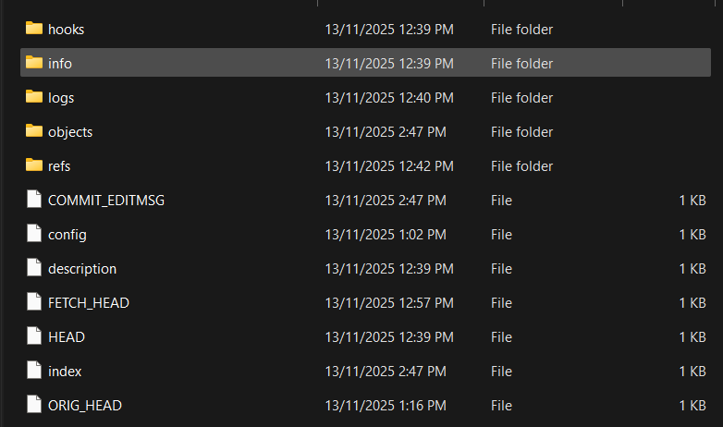
hooks/: A folder for custom scripts that run at certain Git events (e.g., before a commit).
Info: It's used to store optional, repository-specific metadata and configuration files that aren't essential for Git's core operations but can customize behaviour.
logs/: Keeps a record of changes to references (like branch movements) for recovery purposes.
objects: The actual data store: commits, trees (directories), blobs (file contents), tags.
refs/:
refs/heads/ → branches
refs/tags/ → tags
refs/remotes/ → remote branches
Config: Repo-specific settings (remotes, user info, etc.).
HEAD: Points to the current branch (e.g., refs/heads/main).
Index: The staging area (what’s ready to be committed).

- Check all the logs of git.
We can check the logs of git using the ‘git log’ command
This command will show the history of all the commits made and we can see the latest commits on the top and see older once after that
We can able to see the commit ids of the commits made and help us to execute the ‘git revert’ command to get to the desired commits made earlier.
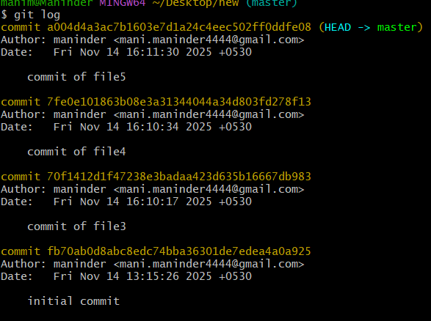
- Rename the commit message.
git commit --amend -m "Your new commit message here" is used to amend the commit messages as follows
git log shows the commit history and we have executed the command git commit –amend -m “This message is to test the rename of commit message”
and after the execution we can see the amended commit message.
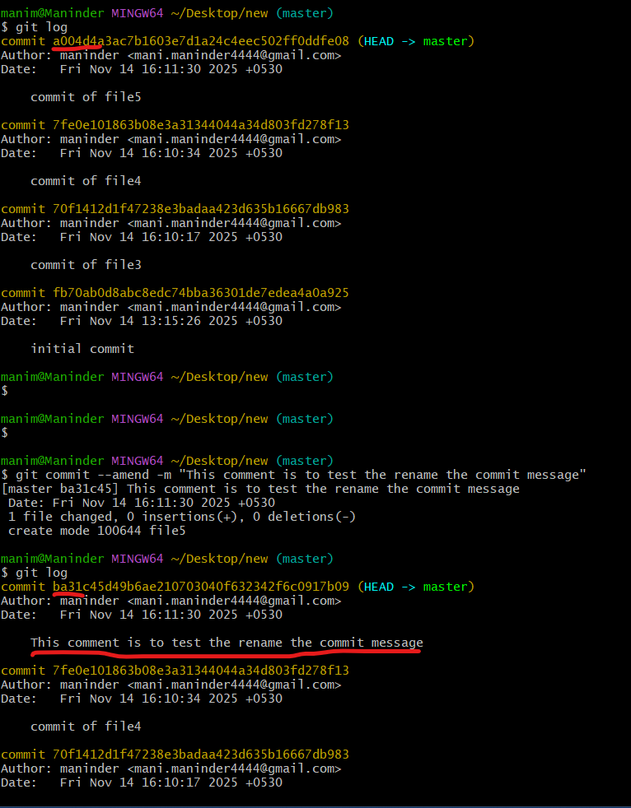

- Merge multiple commits into single commit.
We can able to merge the commits into single commit using the ‘git rebase’ command.
Executed command ‘git log –online’ to see the commits with commit id’s and comments
Executed ‘git rebase -I HEAD~3 to merge the last three commits
Pick the commit you want to merge to and select the other commits to squash the commits from
